- Addition , subtraction, multiplication, modulus, power give integer output.

-When doing division python gives output as floating point.
Eg: 8 / 2 we get as 2.0

-We also have integer division(//) OR floor division which gives output as an integer.
Eg: 5 // 2 gives output as 2 (NOT 2.5)

- We can also do power of any no.
3**2 gives 9 as output.

- Strings can be defined both in single quotes as well as double quotes.

--------------------------------------------------------------------------
Raw String:
A Python raw string is a normal string, prefixed with a r or R .
This treats characters such as backslash (‘\’) as a literal character. This also means that this character will not be treated as a escape character.
Eg: print(r‘navin\navin’)
Gives O/P : navin\navin
instead of : navin
avin
--------------------------------------------------------------------------------

- Underscore(_) can be used to refer to previous output,
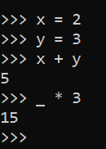
Eg:

Array Indices:
-If we use negetive indices , it starts from last element,
i.e. array[-1] will give us the last element.

-We can also get sub-arrays by giving the range.
Range can be given with colon(:)

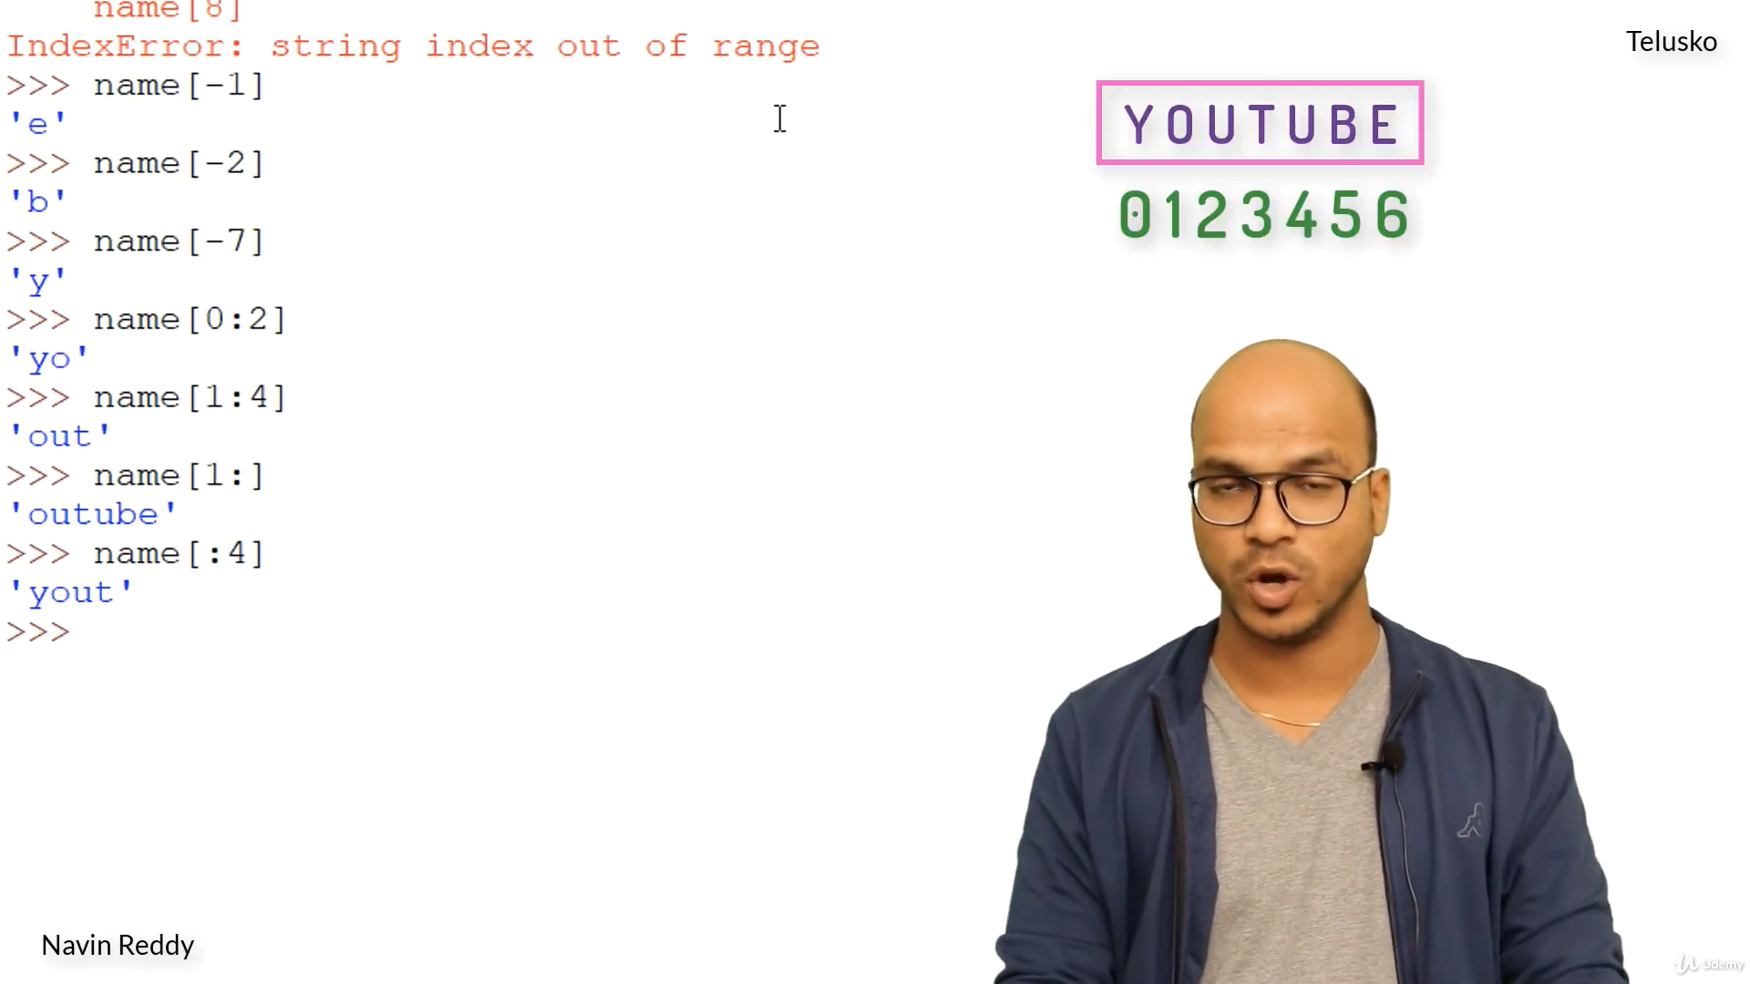
Eg:

----------------------------------------------------------------------

*Strings in python are immutable, i.e. cannot change value of it.

-There is len() built in function that can be used to get length of strings, arrays , etc, .
Length Not the size.

